Dictionary

Program 1: constructing set and dict comprehensions as well.
print({x for x in 'abcddeef' if x not in 'abc'})
print({x: x**2 for x in range(5)})

OUTPUT:

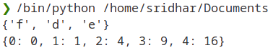

Program 2: merge dictionary and square of no. in dict

dict1 = {'a': 1, 'b': 2}
dict2 = {'c': 3, 'd': 4}
merged_dict = {**dict1, **dict2}
print("Merged dictionary:", merged_dict)

n = 5
squares = {x: x**2 for x in range(1, n+1)}
print("Squares up to", n, ":", squares)

OUTPUT
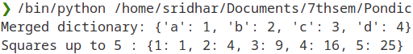
Program 3:

dict1 = {"a": 1, "b": 2}
dict2 = {"c": 3}
dict1.update(dict2)
print(dict1)

# If they have same keys:
dict1.update({"c": 4})
print(dict1)
OUTPUT:
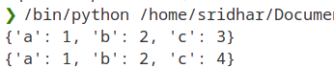

Lists

Program 1: Program to check if a string is a palindrome using list slicing

string = "radar"
if string == string[::-1]:
print("Palindrome")
else:
print("Not a palindrome")

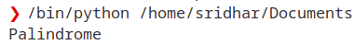
OUTPUT:

Program 2: progam for fibonacci sequence using list

n = 10
a, b = 0, 1
fibonacci_sequence = [a, b]
for _ in range(n - 2):
a, b = b, a + b
fibonacci_sequence.append(b)
print("Fibonacci sequence:", fibonacci_sequence)

OUTPUT:
Program 3: program using list in-build functions

numbers = [1, 2, 3, 4, 2, 5, 2, 6, 2, 7]
count_of_2 = numbers.count(2)
print("Number of occurrences of 2:", count_of_2)

values = (-x for x in [1,2,3,4,5])
gen_to_list = list(values)
print(gen_to_list)

OUTPUT:
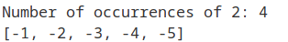

Sets

Program 1: To add or pop values from a set

set1 = {1, 2, 3, 4, 5}
set2 = {4, 5, 6, 7, 8}
intersection = set1.intersection(set2)
print("Intersection of sets:", intersection)

set1 = {1, 2, 3, 4, 5}
set2 = {4, 5, 6, 7, 8}
union = set1.union(set2)
print("Union of sets:", union)

OUTPUT:
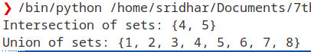

Program 2: Program to find the difference between two sets:
set1 = {1, 2, 3, 4, 5}
set2 = {4, 5, 6, 7, 8}
difference = set1.difference(set2)
print("Difference of sets (set1 - set2):", difference)

OUTPUT:
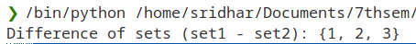

Program 3:

set1 = {1, 2, 3}
set2 = {1, 2, 3, 4, 5}
is_subset = set1.issubset(set2)
print("Is set1 a subset of set2?", is_subset)

OUTPUT:
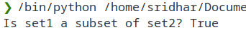
Tuple

Program 1: Program to check if an element exists in a tuple

my_tuple = (10, 20, 30, 40, 50)
element = 30
if element in my_tuple:
print(element, "exists in the tuple")
else:
print(element, "does not exist in the tuple")

OUTPUT:
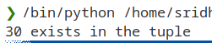

Program 2: Program to find min and max using tuple

my_tuple = (10, 20, 30, 40, 50)
maximum = max(my_tuple)
minimum = min(my_tuple)
print("Maximum element:", maximum)
print("Minimum element:", minimum)

OUTPUT:
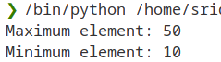

Program 3: Swaping numbers using tuple

a = 5
b = 10
print("Before swapping: a =", a, ", b =", b)
a, b = b, a
print("After swapping: a =", a, ", b =", b)

OUTPUT:
